P.O. Box 402  Salem, NY 12865
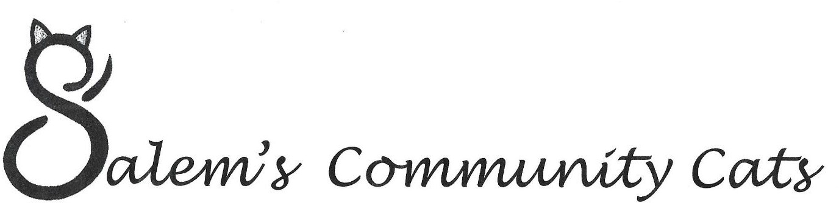

Adoption Policies

Adoption fees for our cats cover spay/neuter & vaccination expenses plus flea treatment and de-worming when necessary. The adoption fee is typically $135 or less. We incur expenses exceeding the adoption fee while cats are in our care.

We ask that you complete an adoption application if you’re looking to adopt one of our kitties so we can be sure you will provide him or her with a good life.

As part of the application process, you agree to provide veterinary treatment for the duration of the cat’s life. You also agree to return the cat to us in the event that the placement doesn’t work out, or if a situation arises making it impossible for you to continue caring for the cat.

No cat adopted from Salem’s Community Cats is to be declawed. Ever. This is a painful and unnecessary surgery. When adopting a cat from SCC, you also agree to keep the cat indoors.

If you are a renter, we will need permission from your landlord before placing a cat in your home to live. We also perform reference checks.

We have many rescued cats and kittens in need of good homes. By adopting one of our kitties (or better yet two!) you are not only saving their life, you are also making room for us to save another cat! Help us help the cats in Salem!

